PROJECT

ABMS


Submitted to:
SIR KHURAM

Submitted By:

MUHAMMAD sanaullah khan | 23-CS-185
Zainab bibi | 23-cs-097
Muhammad hammad abbasi | 23-cs-005

Department of Computer Science,
HITEC University, Taxila

Advanced Database Management System

Project Title
Inventory Management System (IMS)

1. Introduction
This project implements a complete Inventory Management System using Microsoft SQL Server (T-SQL). The system manages suppliers, products, sales, stock movements, and reporting. It demonstrates advanced DBMS concepts including relational design, constraints, stored procedures, triggers, views, functions, transactions, cursors, indexing, and error handling.

2. Project Selection Rationale
Inventory Management is a real-world system with complex relationships, frequent transactions, integrity constraints, and reporting needs. It is well-suited to demonstrate advanced database concepts such as transactional consistency, automated stock control via triggers, and summarized dashboards using views.

3. Database Design

Entities
- Suppliers
- Products
- Sales
- StockHistory
- ErrorLog
- SalesReportOutput

Relationships
- One Supplier → Many Products
- One Product → Many Sales
- One Product → Many StockHistory records

Normalization
The schema is normalized up to 3NF:
- No repeating groups
- No partial dependencies
- No transitive dependencies

4. DDL – Database Schema

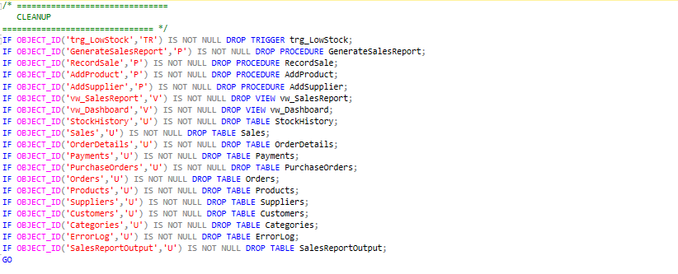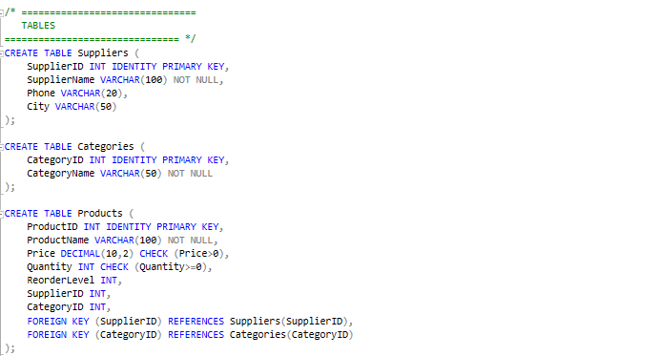

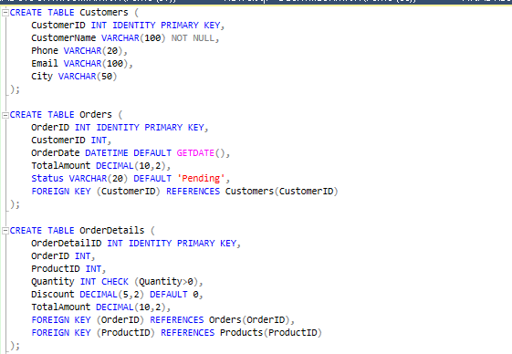

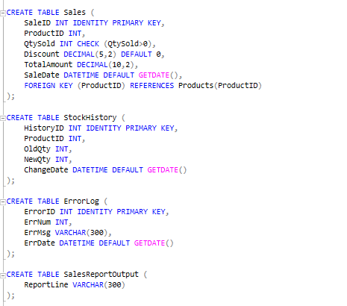

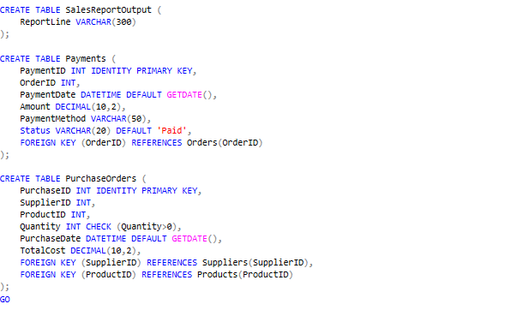

5. Sample Data (DML)

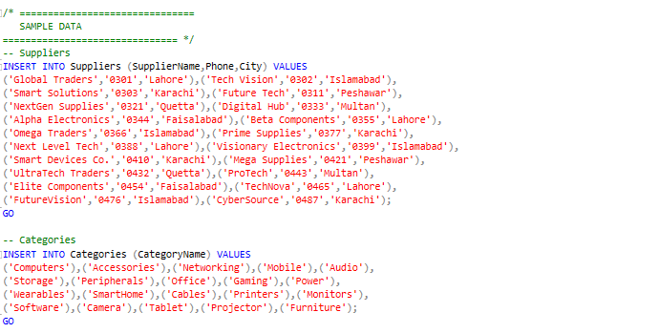

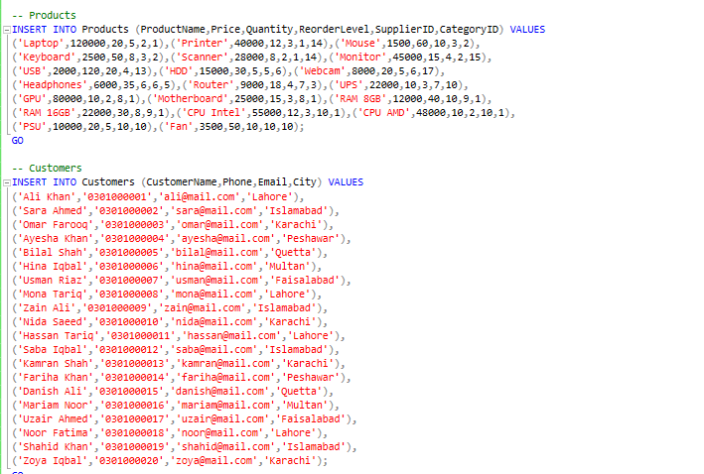

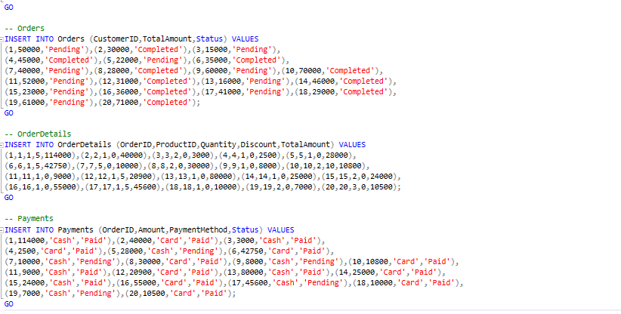

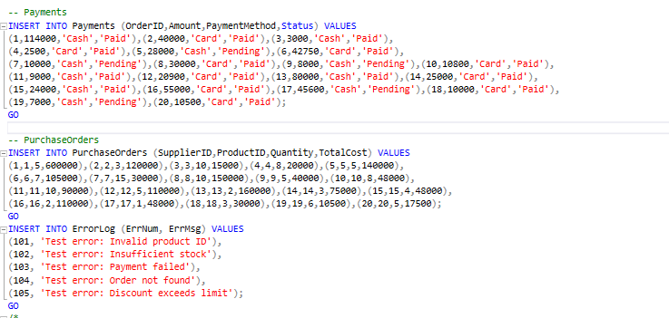

6. Stored Procedures

AddSupplier and AddProduct

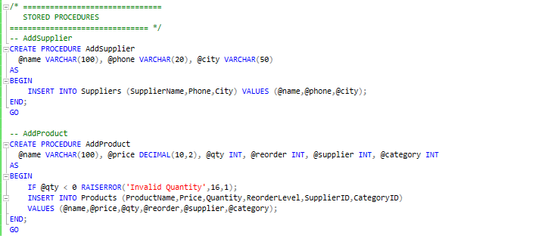

RecordSale (Transaction + Error Handling)

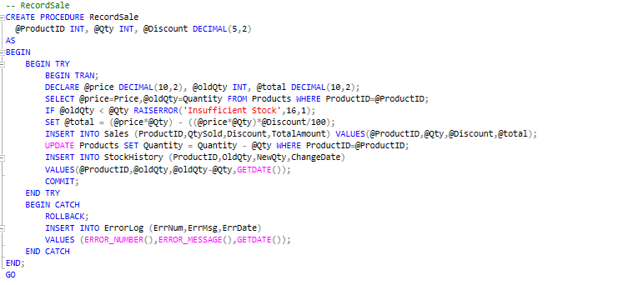

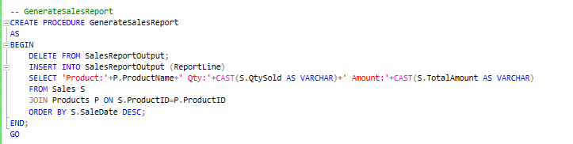

7. Triggers

Low Stock Alert Trigger
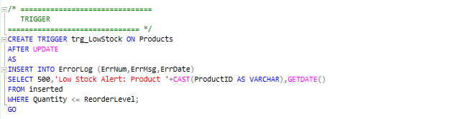

8. Views
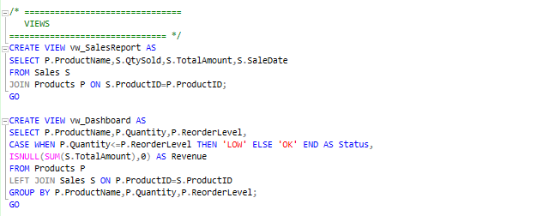

9. Cursor-Based Report
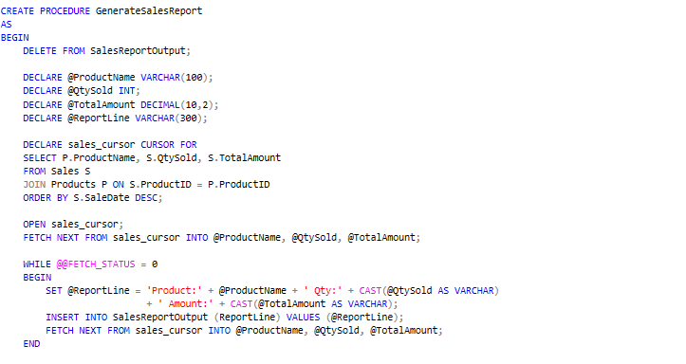

10. Testing

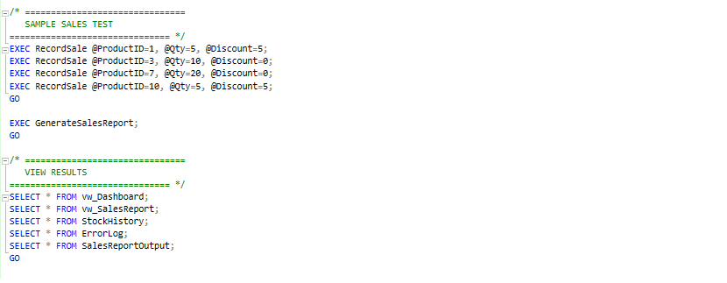

Output:

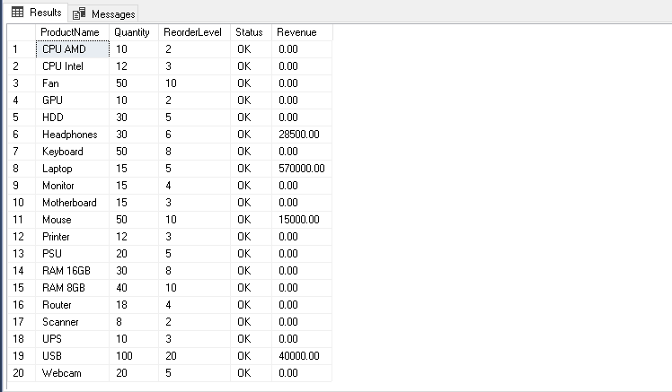

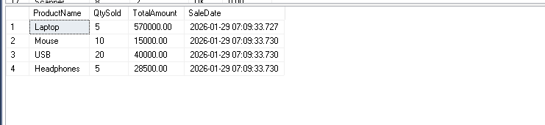

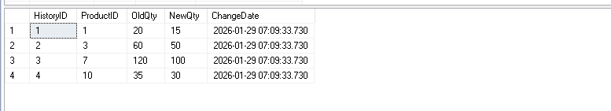

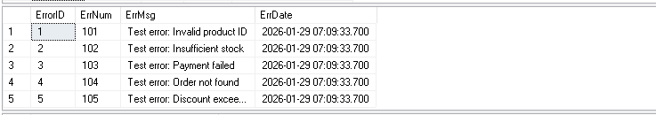

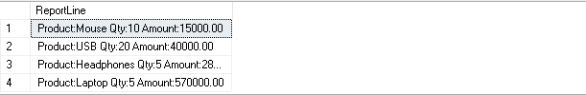

11. Conclusion
This project fulfills all Advanced DBMS requirements. It ensures data integrity, automated stock control, transactional safety, and efficient reporting. The system is scalable and can be extended with user roles, audit logs, and web/mobile interfaces.

